

Business Workflow & Functional Specification

Document Type:
Business Analysis & Functional Specification

Project:
Halo AI

Date:
September 2026

Version:
Version 1.0

Halo AI – Overview and Business Context
Introduction
Halo AI is an AI-powered capability integrated into the Halo service management platform to support users and service teams in handling service-related requests efficiently. It combines conversational AI, organisational knowledge, service data, and workflow automation to assist users in finding information, resolving common issues, and initiating service requests when further assistance is required.
Halo AI is designed to work as part of the existing service workflow rather than as a standalone chatbot. It can assist in understanding user requests, providing relevant information, suggesting solutions, and supporting service teams in managing requests and tickets.
How Halo AI Helps Clients
Halo AI helps clients improve their service operations by reducing manual effort and providing users with faster access to relevant support.
The key areas where Halo AI provides value include:
- AI-Assisted Support - Understands user queries and provides relevant responses or recommendations.
- Self-Service - Helps users find information and resolve common issues without requiring immediate assistance from a service agent.
- Request Management - Supports the handling of service requests and tickets through the defined workflow.
- Intelligent Recommendations - Can provide relevant knowledge, suggestions, and contextual information to assist users and service agents.
- Automation - Supports repetitive service activities and helps streamline operational workflows.
- Agent Assistance - Provides service teams with relevant information and AI-generated assistance while handling requests.
- Escalation - Allows unresolved or complex requests to move into the appropriate human support workflow.
Overall, Halo AI helps clients create a more efficient service experience by combining AI assistance with their existing service management processes.

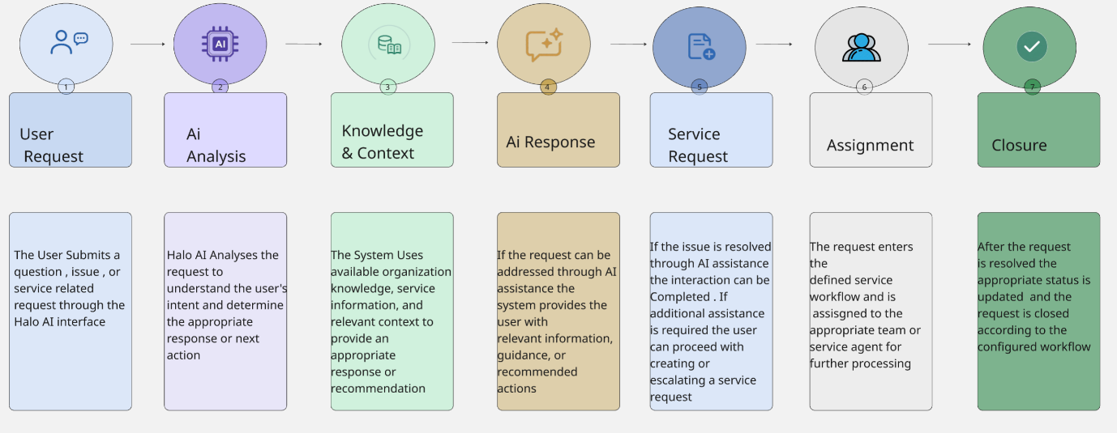
High-Level Business Workflow

Workflow Description
- User Request - The user submits a question, issue, or service-related request through the Halo AI interface.
- AI Analysis - Halo AI analyses the request to understand the user's intent and determine the appropriate response or next action.
- Knowledge & Context - The system uses available organisational knowledge, service information, and relevant context to provide an appropriate response or recommendation.
- AI Response / Recommendation - If the request can be addressed through AI assistance, the system provides the user with relevant information, guidance, or recommended actions.
- Resolution or Service Request - If the issue is resolved through AI assistance, the interaction can be completed. If additional assistance is required, the user can proceed with creating or escalating a service request.
- Assignment & Processing - The request enters the defined service workflow and is assigned to the appropriate team or service agent for further processing.
- Closure - After the request is resolved, the appropriate status is updated and the request is closed according to the configured workflow.

Business Objective
The primary objective of integrating Halo AI is to provide an intelligent and streamlined service experience while improving operational efficiency.
The solution aims to:
- Reduce repetitive manual activities.
- Improve the speed of service request handling.
- Enable users to obtain support through self-service.
- Provide relevant information and recommendations to service teams.
- Support consistent service workflows.
- Improve the overall user and service-agent experience.
Scope of this Documentation
This documentation establishes the business context and high-level workflow for Halo AI and provides a foundation for the UI/UX and functional requirement specifications.
The UI/UX section defines the screens, components, placement, and navigation, while the Functional Requirements section defines the expected system behaviour and user interactions associated with those screen

S.No | Screen/Page | Type | Purpose
1 | Dashboard | Screen | Provides a personalized overview of tickets, approvals, assignments, and tasks for the logged-in user
2 | Incidents | Screen | Displays incident analytics with priority and category charts, recent incidents, and new tickets
3 | My Work - Ticket List (Collapsed Nav) | UI State – Collapsed Navigation | Shows the agent's personal ticket queue organized by Active, Pending, and Actioned status
4 | My Work - Ticket List (Expanded Nav) | UI State – Expanded Navigation | Same ticket queue view with full left sidebar navigation expanded
5 | Projects | Screen | Lists active projects with completion status, timeline, time spent, and associated sub-tasks
6 | Services Catalogue | Screen | Allows users to browse all available services by category and submit requests
7 | My Approvals | Screen | Displays pending approval requests with options to approve or reject each item
8 | Login | Screen | Allows users to securely access Halo AI using their username and password
9 | My Work - On Hold Tickets | Screen – Ticket List View | Enables agents to switch ticket views and review on-hold tickets with SLA and priority details
10 | Change Requests | Screen | Lists all change requests categorized by status, type, CI tag, and scheduled dates
11 | New List - Create List Form (Design) | Screen – Create Form | Form for creating a custom ticket list with name, group, column profile, and display settings
12 | Incidents by Team - 1st Line Support (Design) | Screen – Team View | Shows open incidents assigned to 1st Line Support agents with SLA timers and priority
13 | Incidents by Team - 2nd Line Support (Design) | Screen – Team View | Displays open incidents under 2nd Line Support with SLA countdown and priority columns
14 | Splash / Sign-In Loading Screen | Loading State | Shown after authentication while the system loads the user session
15 | Home Dashboard (Live) | Screen | Live dashboard showing KPIs including open incidents, SLA breaches, resolution times, and mood check-in
16 | Home Dashboard -Scrolled View (Live) | UI State – Scrolled View | Continuation of live dashboard showing incidents by team, category breakdown, and new tickets panel
17 | My On Hold Tickets (Live) | Screen – Ticket List View | Lists all on-hold tickets filterable by type with SLA time, priority, organisation, and status
18 | New List - Create List Form (Live) | Screen – Create Form | Live form to configure a custom ticket list with name, scope, group, and column profile
19 | Incidents by Team -1st Line Support (Live) | Screen – Team View | Shows live open incidents for 1st Line Support with agent availability and SLA countdown
20 | Incidents by Team - 2nd Line Support (Live) | Screen – Team View | Displays live open incidents for 2nd Line Support with agent list and ticket details
21 | Organisations - Users List (Design) | Screen – User List | Lists all organisation users with site, email, phone number, and network login details
22 | Major Incidents with Activity Feed (Design) | Screen – Detail View | Shows active major incidents with lifecycle stages and a live activity feed panel
23 | Major Incidents - Update Required (Live) | Screen – Update View | Lists major incidents filtered to Update Required with full resolution pipeline visible
24 | Major Incidents - Update Required with Feed (Live) | Screen – Update View + Activity Feed | Same major incidents view with Activity Feed panel open showing real-time ticket updates
25 | CMDB Configuration Items (Design) | Screen – Configuration Item List | Lists all configuration items grouped by type with CI tag, site, status, and business owner
26 | Major Incidents List View (Mockup) | Screen – List View | Figma mockup of incident cards showing lifecycle pipeline, priority badges, and product tags
27 | Change Requests -All Active Changes (Live) | Screen – List View | Live change requests list with agent, change type, status, CI tags, and start and end dates
28 | Projects Active - Projects (Live) | Screen – Project List | Live projects view showing completion percentage, timeline, time spent, and linked sub-tasks
29 | Article Drafts (Live) | Screen– Article List | Lists knowledge base article drafts with SLA time remaining, category, priority, and approval status
30 | Calendar (Live) | Screen | Weekly agent scheduling calendar with appointment type filters and per-agent calendar views
31 | Organisations- Users List (Live) | Screen – User List | Live list of organisation users with contact details across EMEA, APAC, and Americas regions
32 | CMDB - Service CIs (Live) | Screen – Service CI List | Live CMDB view filtered to Service group showing Business and Technical Services with owner details
33 | My Approvals (Live) | Screen | Live approvals page with full navigation and pending requests with approve and reject actions
34 | Services Catalogue (Live) | Screen | Live catalogue of 67 services grouped by category with icons and request submission options
35 | Article Drafts (Design) | Screen – Article List | Figma design of Article Drafts showing open drafts with SLA time, category, priority, and status
36 | Calendar (Design) | Screen | Figma design of weekly calendar with appointment types and agent calendar toggle options

Screen-wise UI/UX Details
This section describes the UI/UX structure of the screens identified in the Halo AI application design. It covers the purpose of each screen, major UI components, information displayed, and navigation or interaction elements relevant to the frontend implementation.
Dashboard
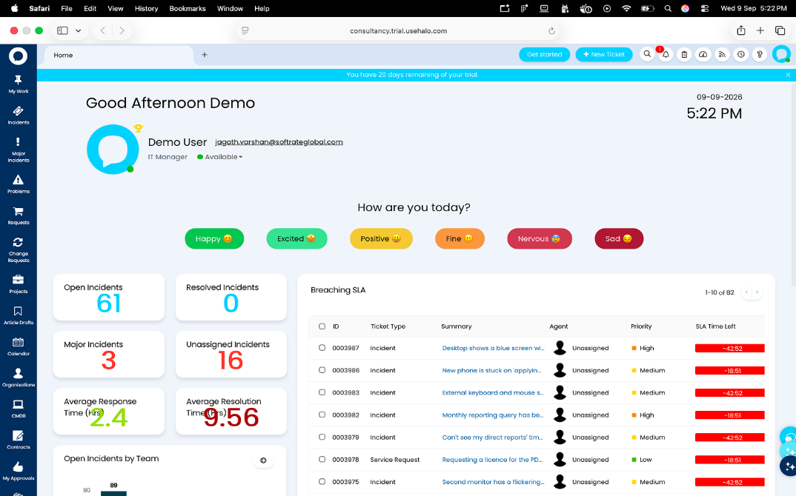
Purpose:
Provides an overview of key service activities and work items.

UI Components:
- Header
- Navigation panel
- Ticket status section
- Upcoming tasks section
- Incident information section
- Ticket summary sections
Displayed Information:
- Tickets by Status
- Upcoming Tasks
- Incidents by Priority
- Recent Incidents
- My New Tickets
Navigation:
Users can select relevant tickets, incidents, or tasks to access their respective details.
Incidents
Purpose:
Provides an overview of incident-related information and recently created or active incidents.
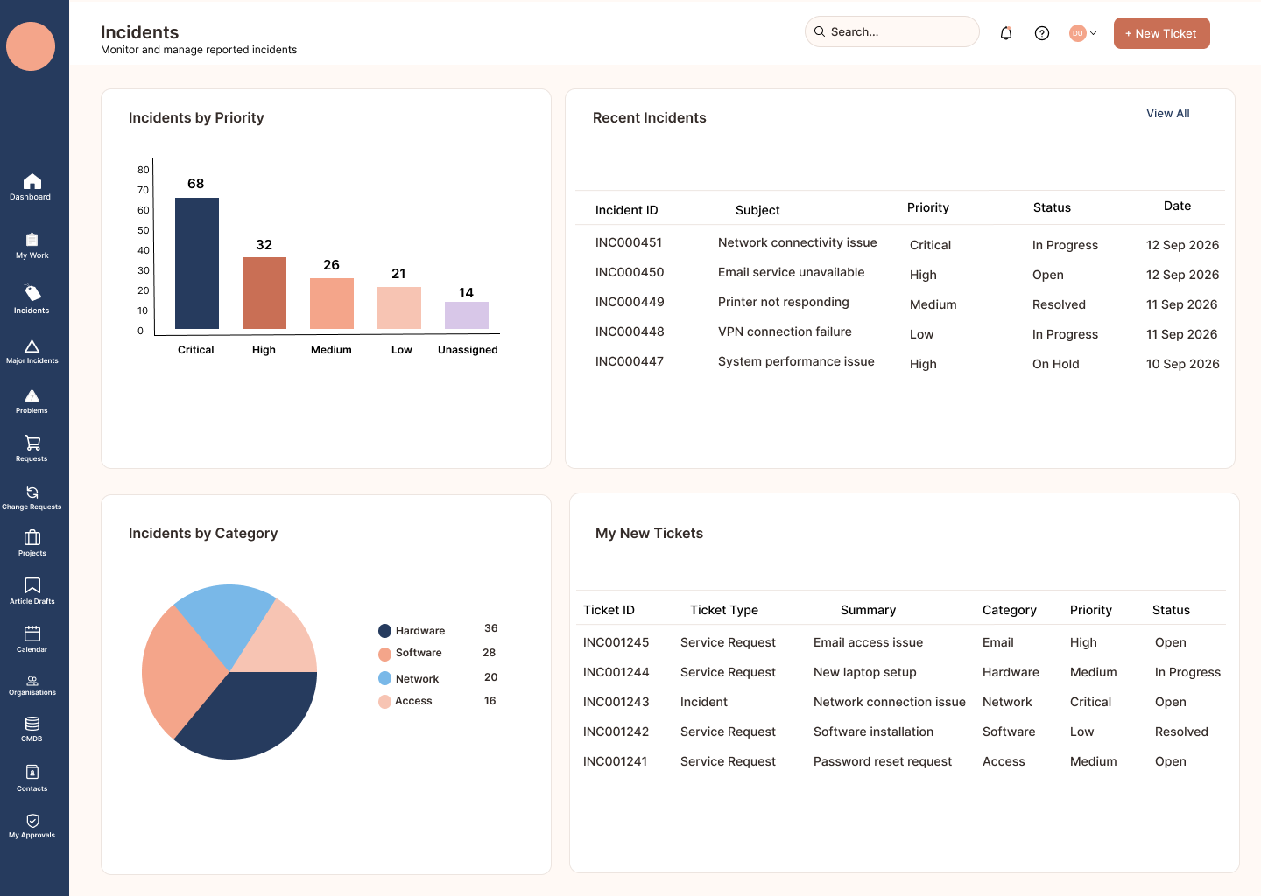

UI Components:
- Incident summary section
- Priority-based incident display
- Recent incidents section
- New tickets section
- Navigation controls
Displayed Information:
- Incidents by Priority
- Recent Incidents
- My New Tickets
Navigation:
Users can select an incident or ticket to view additional information.
My Work – Ticket List (Collapsed Navigation)
Purpose:
Allows users to view their assigned work items while the navigation panel is collapsed.
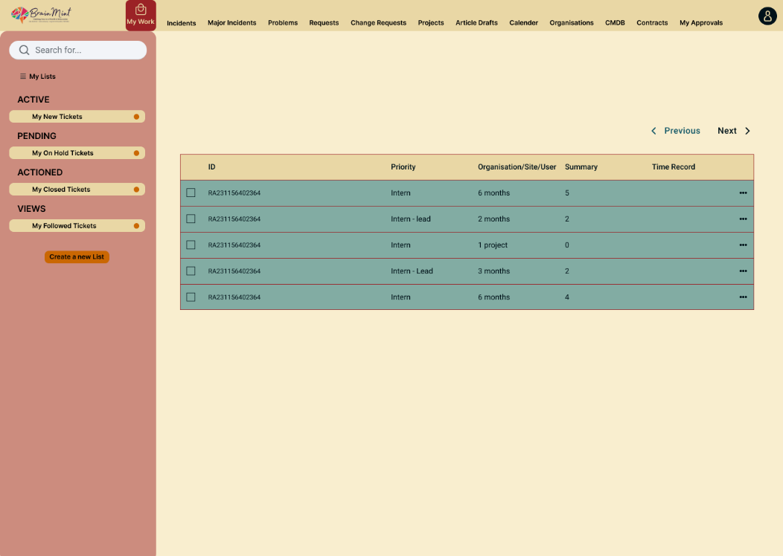
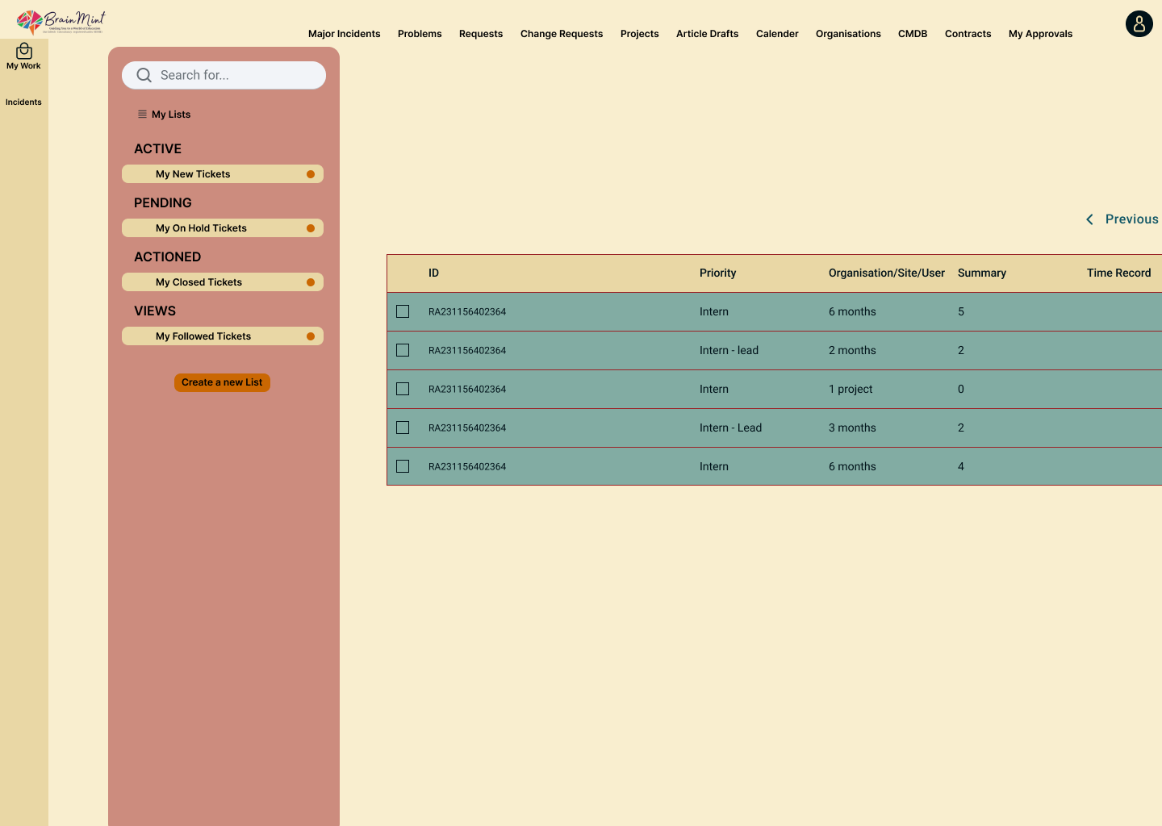
UI Components:
- Collapsed navigation panel
- Ticket list/table
- Header
- Search/filter controls, where available
Displayed Information:
- ID
- Priority
- Organisation
- Summary
- Time Record
Navigation:
Users can select a ticket to access the corresponding ticket details.
My Work – Ticket List (Expanded Navigation)
Purpose:
Provides the same ticket-list view with the navigation panel expanded for easier access to application modules.
UI Components:
- Expanded navigation panel
- Ticket list/table
- Header
- Search/filter controls
Displayed Information:
- ID
- Priority
- Organisation
- Summary
- Time Record
Navigation:
The expanded navigation provides access to other application sections. Users can also select individual tickets.
Projects
Purpose:
Allows users to manage and track active projects.
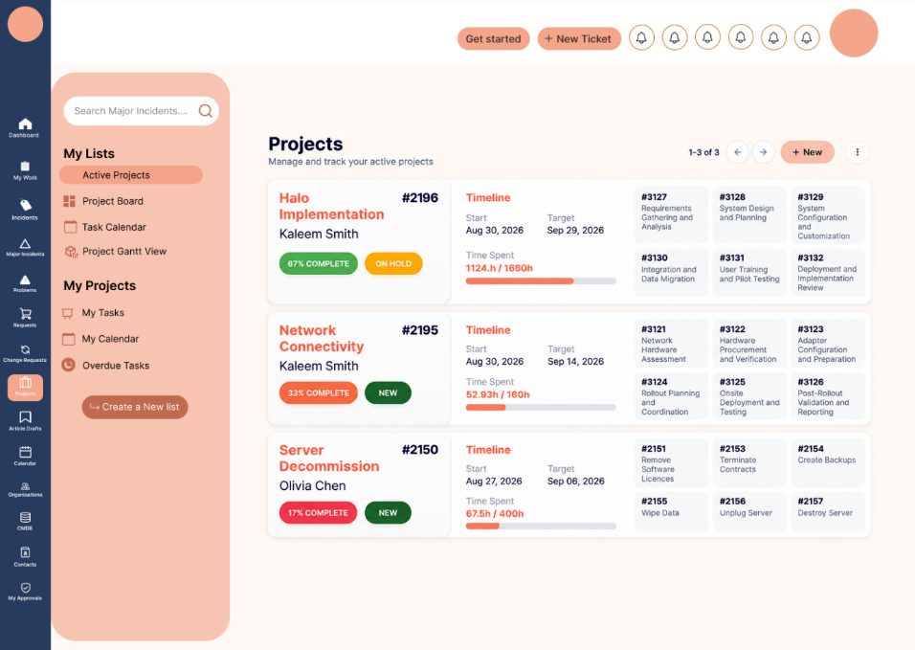
UI Components:
- Project list
- Project information
- Timeline
- Navigation controls
- Project actions

Displayed Information:
- Active projects
- Project timeline
- Project-related information
Navigation:
Users can select a project to access its relevant information.
Services Catalogue
Purpose:
Provides users with access to the available services within the service catalogue.

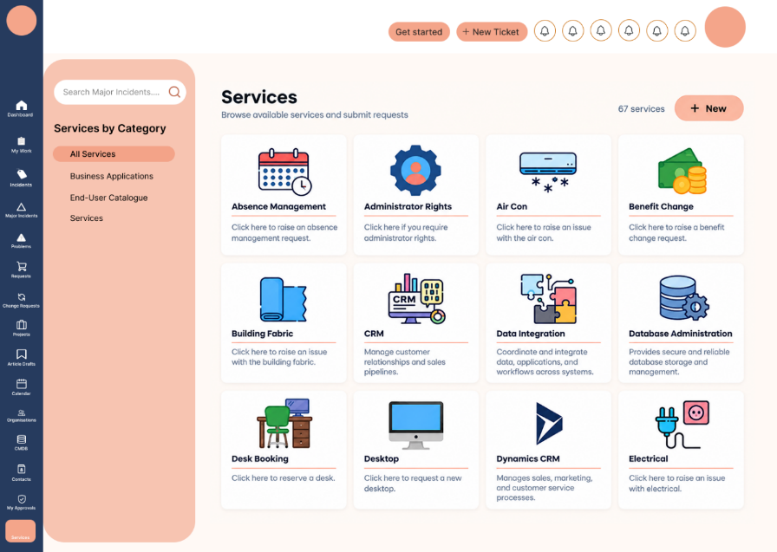
UI Components:
- Service list/cards
- Service categories
- Search/navigation controls, where available
Displayed Information:
- Absence Management
- Air Conditioning
- Administrator Rights
- Benefit Exchange
- Other available services
Navigation:
Users can select a service to access its corresponding information or service request options.
My Approvals
Purpose:
Allows users to review and manage requests that are awaiting their approval.
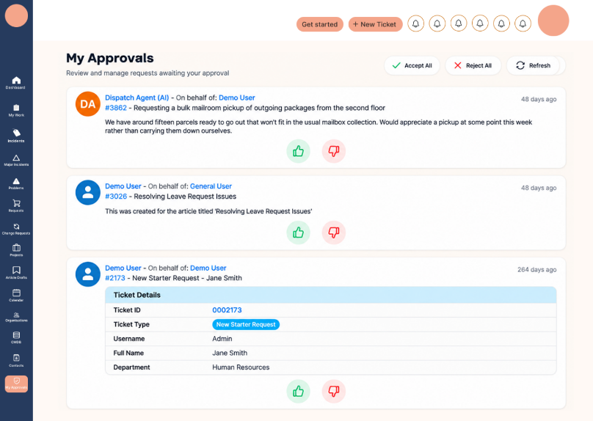
UI Components:
- Approval/request list
- Request information
- Status indicators
- Action controls
Displayed Information:
- Requests awaiting approval
- Request details
- Approval-related information
Navigation:
Users can select an approval item to review its details.

Login
Purpose:
Allows users to authenticate and access the application.
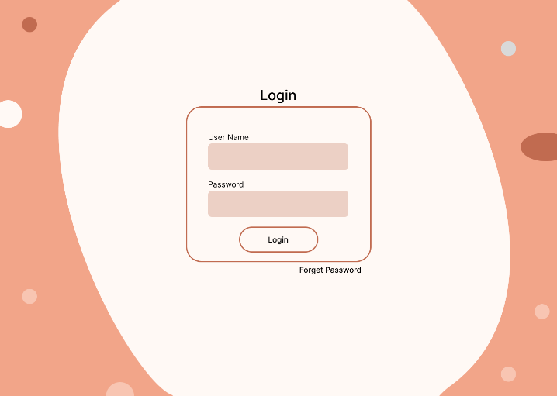

UI Components:
- Username field
- Password field
- Login button
- Application/company branding
Displayed Information:
- Username
- Password
Navigation:
Successful login leads the user to the application loading or home screen.

My Work – On Hold Tickets
Purpose:
Displays tickets assigned to the user that are currently on hold.
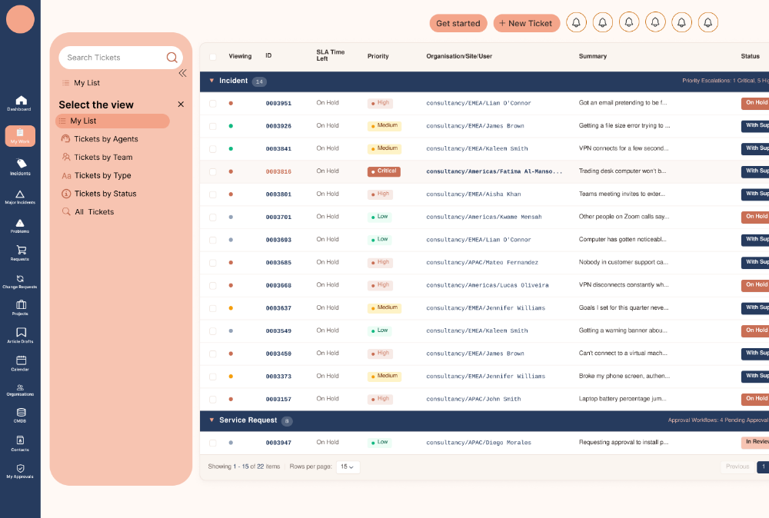

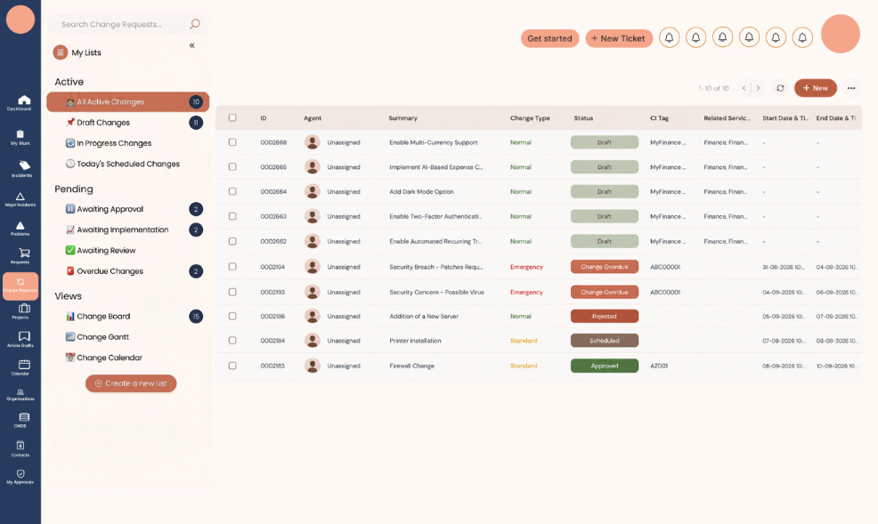
UI Components:
- Ticket list/table
- Navigation panel
- Search/filter controls
- Status indicators
Displayed Information:
- Ticket ID
- SLA Time Left
- Organisation/Site
- Summary
- Status
Navigation:
Users can select a ticket to view its details.

New List – Create List Form (Design)
Purpose:
Provides a form for configuring and creating a new list.
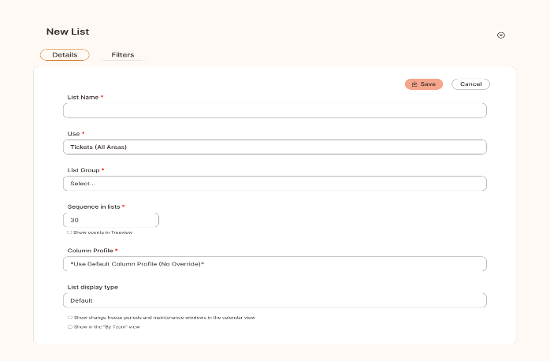
UI Components:
- Input fields
- Dropdown/select controls
- Form sections
- Action buttons

Displayed Fields:
- List Name
- Uses
- List Group
- Sequence in List
- Column Profile
- List Display Type
Navigation:
Users can enter the required information and use the available form actions.

Incidents by Team – 1st Line Support (Design)
Purpose:
Displays incidents associated with the 1st Line Support team.

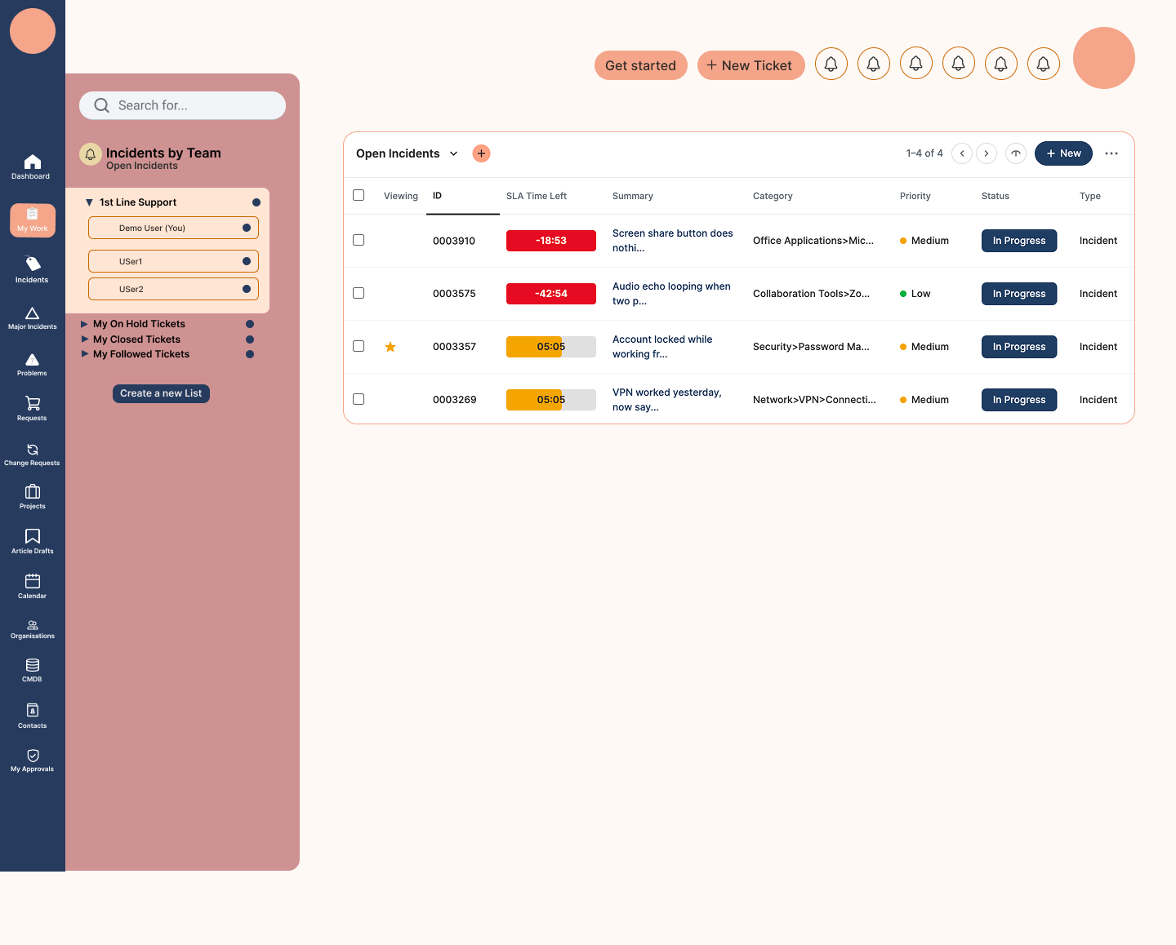
UI Components:
- Incident table/list
- Search/filter controls
- Status indicators
- Navigation controls
Displayed Information:
- Viewing
- ID
- SLA Time Left
- Summary
- Category
- Priority
- Status
- Type
Navigation:
Users can select an incident to access its details.

Incidents by Team – 2nd Line Support (Design)
Purpose:
Displays incidents associated with the 2nd Line Support team.
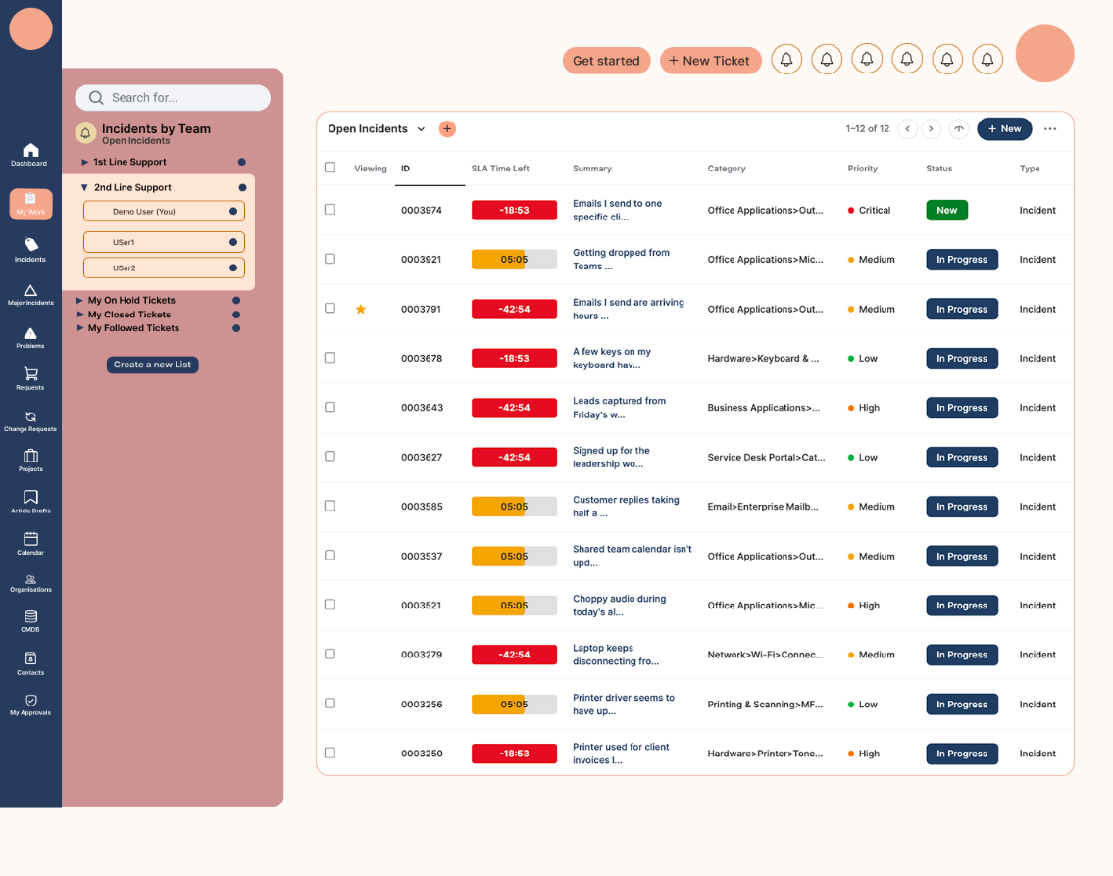
UI Components:
- Incident table/list
- Search/filter controls
- Status indicators
- Navigation controls
Displayed Information:
- Viewing
- ID
- SLA Time Left
- Summary
- Category
- Priority
- Status
- Type
- Navigation:
Users can select an incident to access its details.
Splash / Sign-In Loading Screen
Purpose:
Provides visual feedback while the application is loading and the user is being signed in.
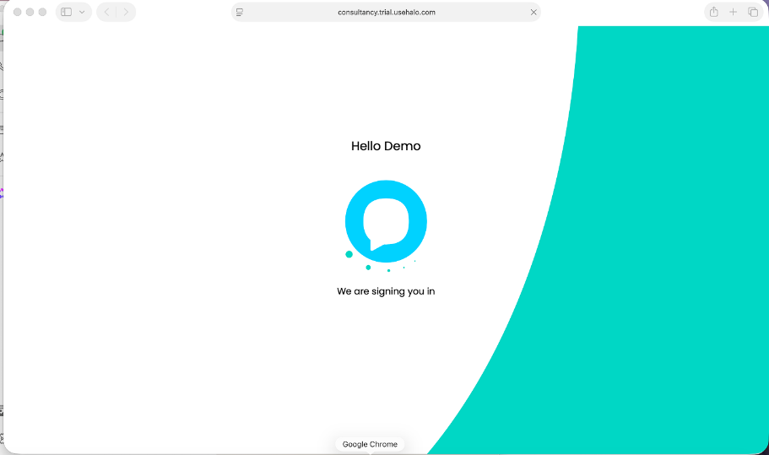
UI Components:
- Application branding
- Welcome message
- Loading indicator, if included in the design
Displayed Information:
- Welcome message such as “Hello Demo”
- Sign-in/loading message
UI State:
Loading state.
Home Dashboard (Live)
Purpose:
Provides the live home dashboard containing the user's main service information and activities.
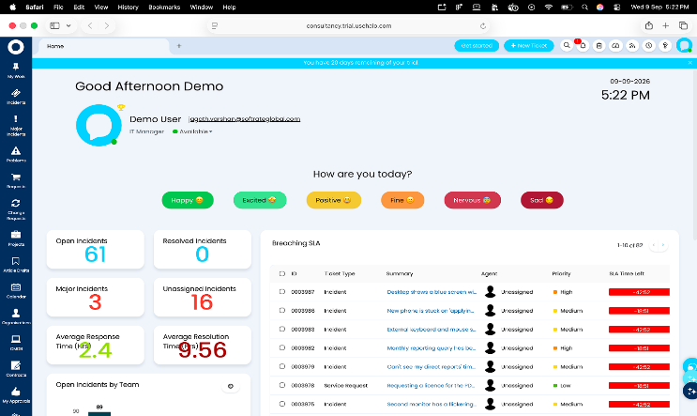
UI Components:
- Header
- Navigation panel
- Dashboard sections
- Summary information
- Service/work information
Displayed Information:
- Home/dashboard information
- Relevant work and service data
Navigation:
Users can navigate to the available application modules through the dashboard or navigation panel.
Home Dashboard – Scrolled View (Live)
Purpose:
Provides the lower/scrollable portion of the live home dashboard.
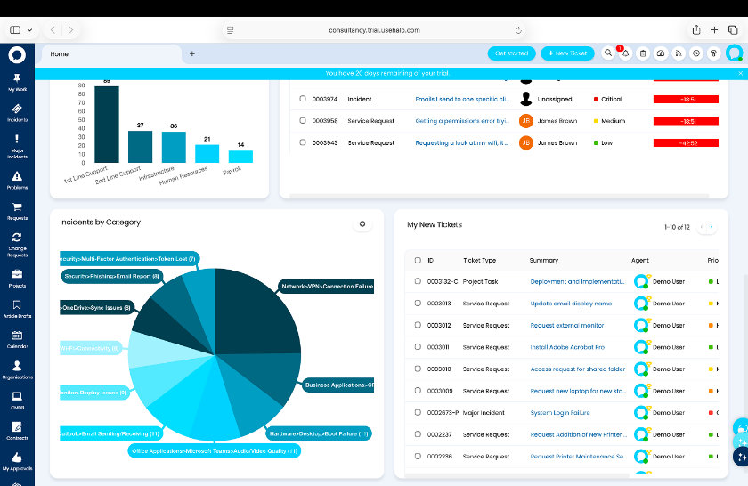
UI Components:
- Dashboard content
- Summary sections
- Charts/widgets
- Scrollable content area
Displayed Information:
- Additional dashboard information available below the initial viewport.
UI State:
Scrolled view of the Home Dashboard.
My On Hold Tickets (Live)
Purpose:
Provides the live view of tickets currently placed on hold.
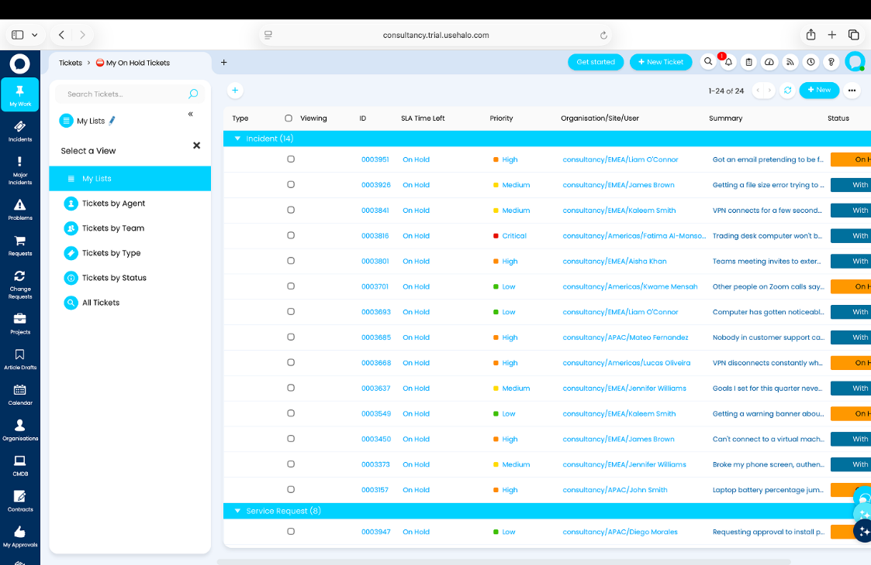
UI Components:
- Ticket list/table
- Navigation
- Search/filter controls
- Status indicators
Displayed Information:
- On-hold tickets
- Ticket information
- Status
- SLA-related information
Navigation:
Users can select an on-hold ticket to view its details.
New List – Create List Form (Live)
Purpose:
Allows users to create and configure a new list in the live application.

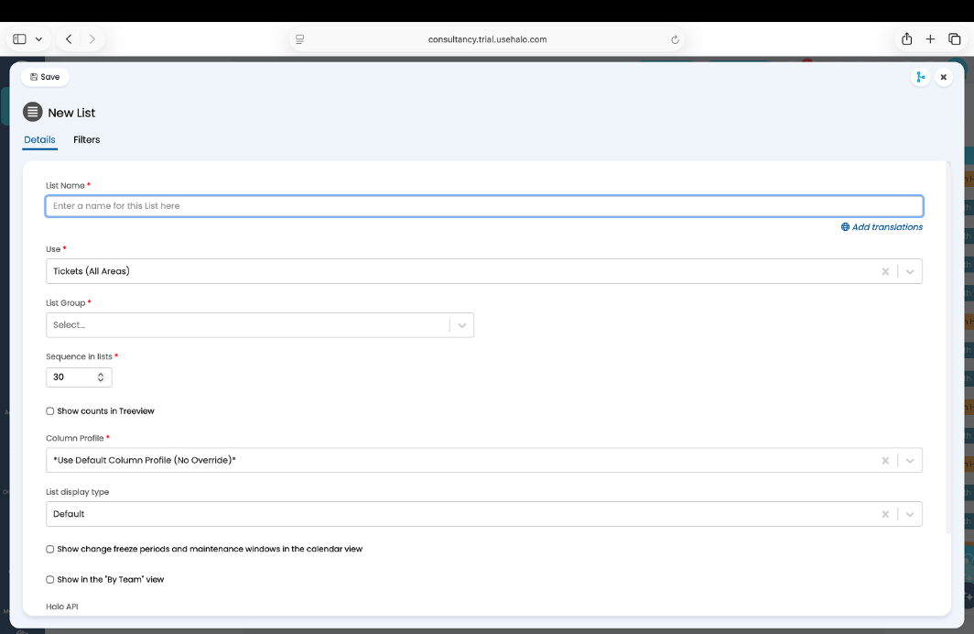
UI Components:
- Form fields
- Dropdown/select controls
- Form actions
Displayed Fields:
- List Name
- Uses
- List Group
- Sequence in List
- Column Profile
- List Display Type
UI State:
Live form.

Incidents by Team – 1st Line Support (Live)
Purpose:
Provides the live view of incidents assigned to the 1st Line Support team.
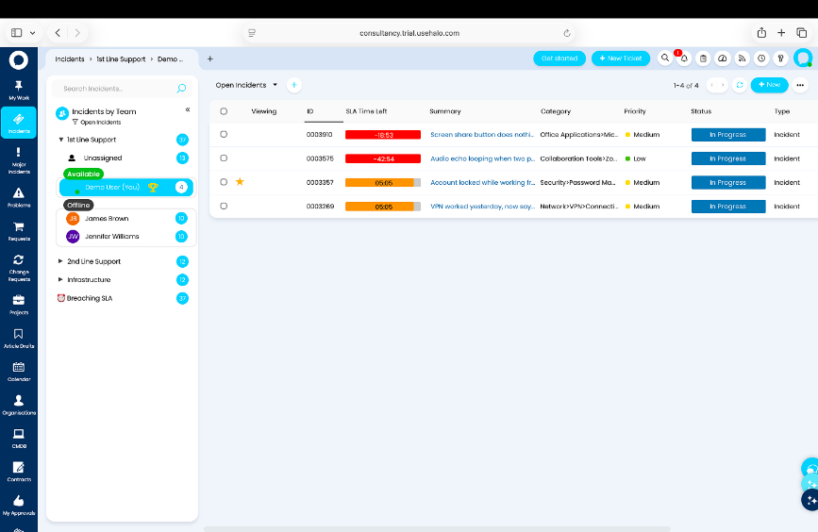
UI Components:
- Incident list/table
- Navigation
- Search/filter controls
- Status indicators
Displayed Information:
- Viewing
- ID
- SLA Time Left
- Summary
- Category
- Priority
- Status
- Type
Navigation:
Users can select an incident to view its details.

Incidents by Team – 2nd Line Support (Live)
Purpose:
Provides the live view of incidents assigned to the 2nd Line Support team.
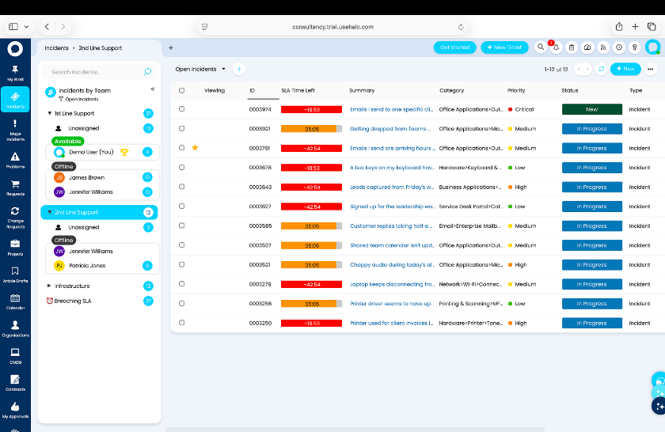
UI Components:
- Incident list/table
- Navigation
- Search/filter controls
- Status indicators
Displayed Information:
- Viewing
- ID
- SLA Time Left
- Summary
- Category
- Priority
- Status
- Type
Navigation:
Users can select an incident to view its details.

Organisations – Users List (Design)
Purpose:
Provides a list of users associated with organisations and their default organisational details.
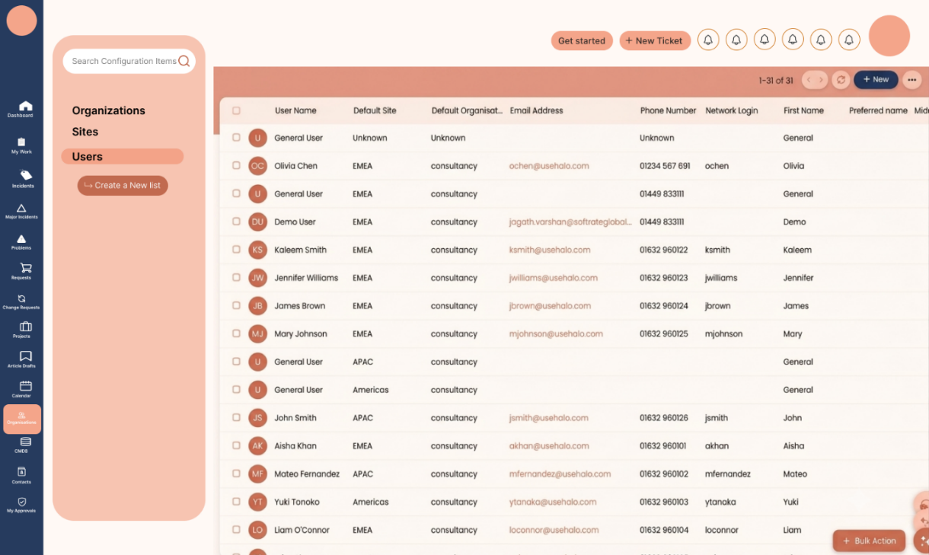
UI Components:
- User list/table
- Search/filter controls
- Navigation controls
Displayed Information:
- Username
- Default Site
- Default Organisation
- Email Address
- Phone Number
- Network Login
- First Name
Navigation:
Users can select a user record to access additional information, where applicable.

Major Incidents with Activity Feed (Design)
Purpose:
Provides a detailed view of a major incident together with its activity history.
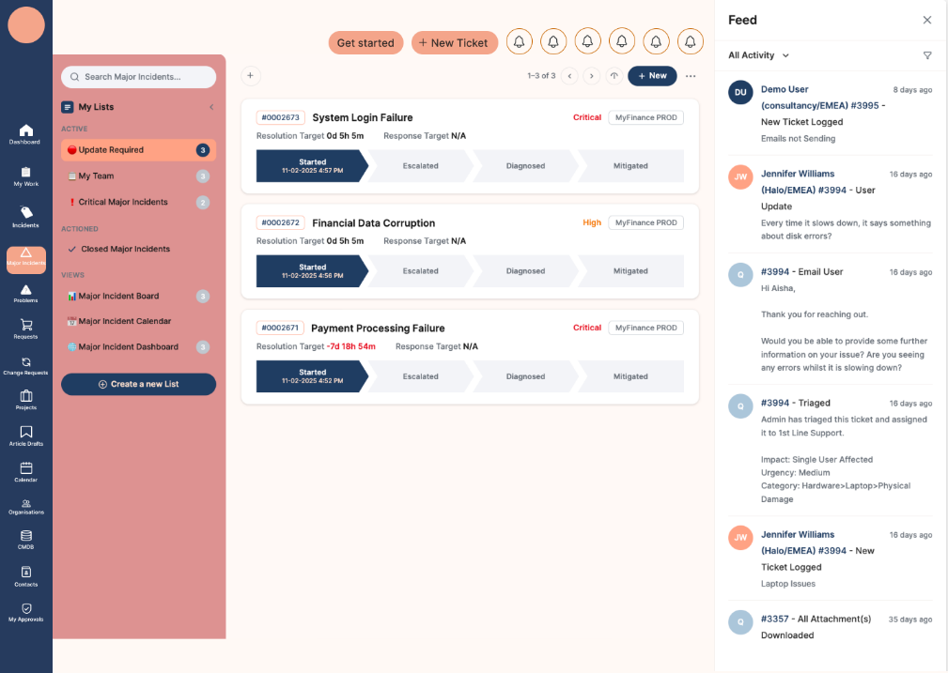
UI Components:
- Major incident details
- Status/timeline section
- Activity feed
- Incident information panel
- Action controls
Displayed Information:
- Incident ID
- Incident summary
- Resolution target
- Response target
- Incident status/progress
- Activity/feed information
Layout:
- Main incident information is displayed in the primary content area.
- Activity feed is displayed in the supporting/right-side panel.

Major Incidents – Update Required (Live)
Purpose:
Displays major incidents that require an update or further action.
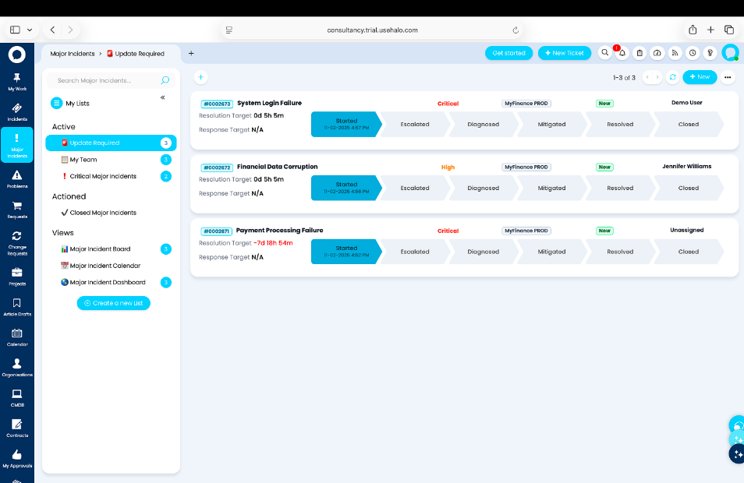
UI Components:
- Major incident information
- Status information
- Update/action controls
- Incident details
Displayed Information:
- Incident ID
- Incident summary
- Resolution target
- Response target
- Incident status
Navigation:
Users can access the relevant major incident for further review or update.

Major Incidents – Update Required with Feed (Live)
Purpose:
Provides the major incident update view together with the associated activity feed.
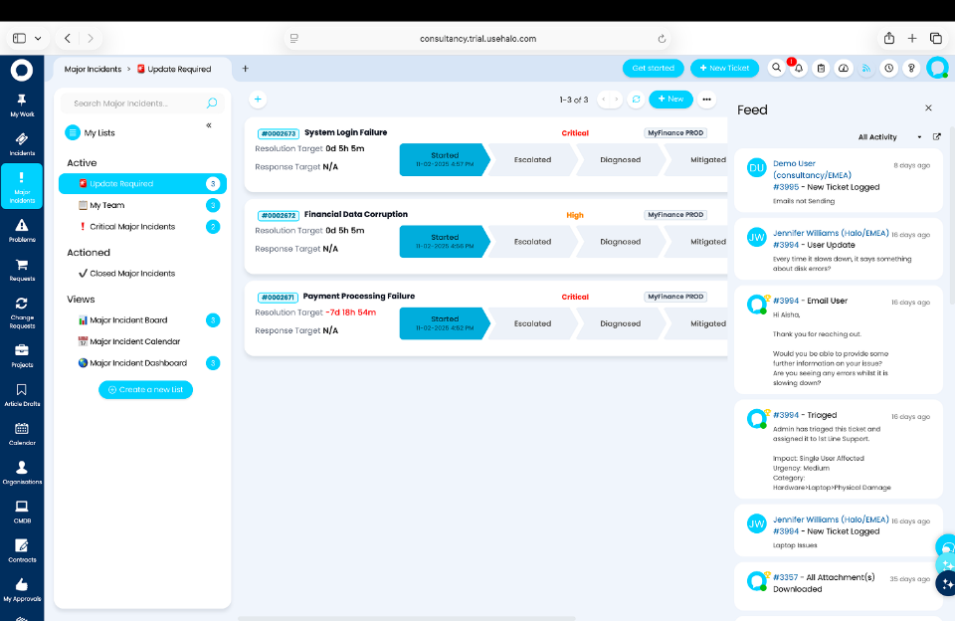
UI Components:
- Incident information panel
- Status/timeline
- Activity feed
- Update controls

Displayed Information:
- Incident ID
- Incident summary
- Resolution target
- Response target
- Activity history
- Incident progress/status
Layout:
- Major incident details are presented in the main content area.
- Activity feed is displayed in the right-side panel.

CMDB – Configuration Items (Design)
Purpose:
Provides a view of configuration items maintained within the CMDB.
UI Components:
- Configuration item table/list
- Search/filter controls
- Navigation controls
- Status indicators
Displayed Information:
- Configuration item information
- Related CMDB information
Major Incidents – List View (Mockup)
Purpose:
Provides a list-based view of major incidents.
UI Components:
- Major incident list/table
- Search/filter controls
- Status indicators
- Navigation controls
Displayed Information:
- Major incident records
- Incident status
- Relevant incident information
UI State:
Mockup.

Change Requests – All Active Changes (Live)
Purpose:
Displays all active change requests in the live application.
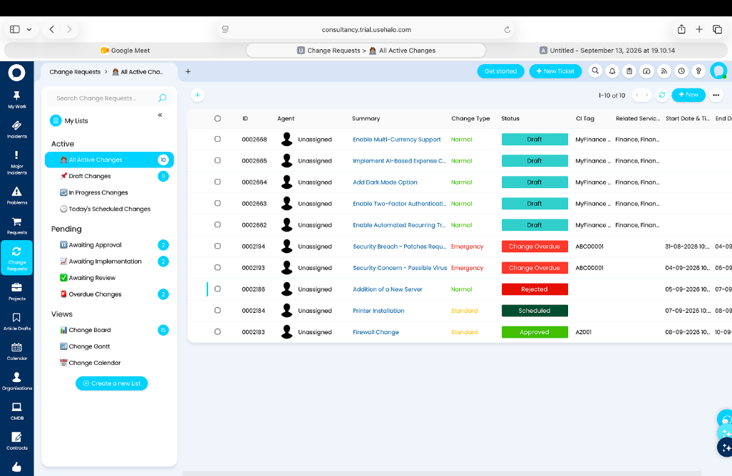
UI Components:
- Change request table
- Search/filter controls
- Status indicators
- Navigation controls
Displayed Information:
- ID
- Agent
- Summary
- Change Type
- Status
- CI Tag
- Related Service
- Start Date and Time
- End Date and Time
Navigation:
Users can select a change record to view its details.

Projects Active – Projects (Live)
Purpose:
Displays currently active projects.
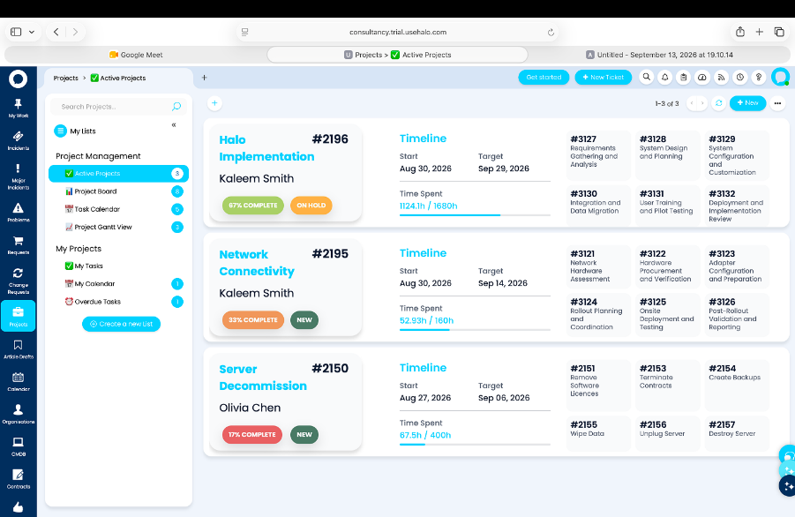
UI Components:
- Project list
- Project information
- Timeline
- Navigation controls
Displayed Information:
- Active projects
- Project timeline
- Project-related information
Navigation:
Users can select a project to view additional project information.

Article Drafts (Live)
Purpose:
Displays draft knowledge articles available in the live application.
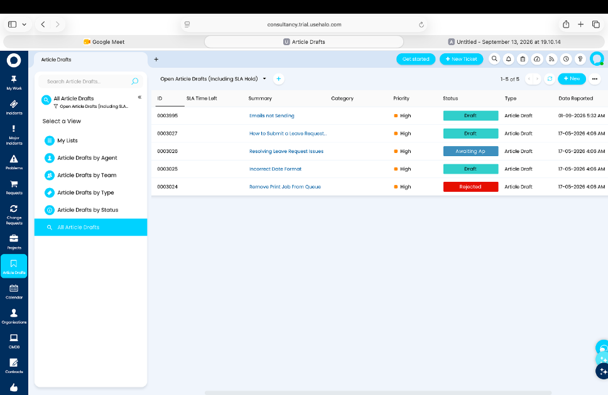
UI Components:
- Article list
- Article information
- Status indicators
- Search/filter controls
Displayed Information:
- Article drafts
- Article status
- Related article information
Navigation:
Users can select an article draft to view or access its details.

Calendar (Live)
Purpose:
Provides a live calendar interface for viewing scheduled activities and events.
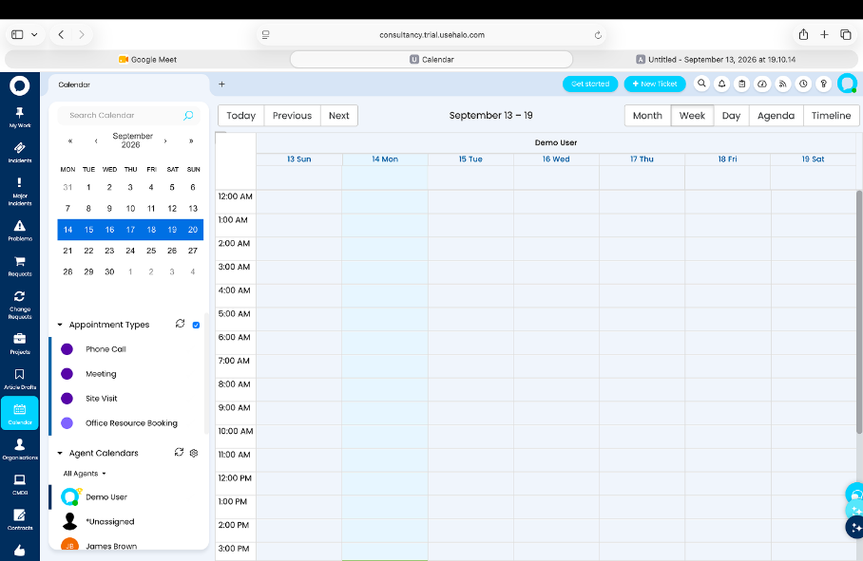
UI Components:
- Calendar grid
- Date navigation
- Event entries
- Calendar controls
Displayed Information:
- Dates
- Scheduled activities/events
- Relevant calendar information
Navigation:
Users can navigate between dates and available calendar views.

Organisations – Users List (Live)
Purpose:
Provides the live user list associated with organisations.
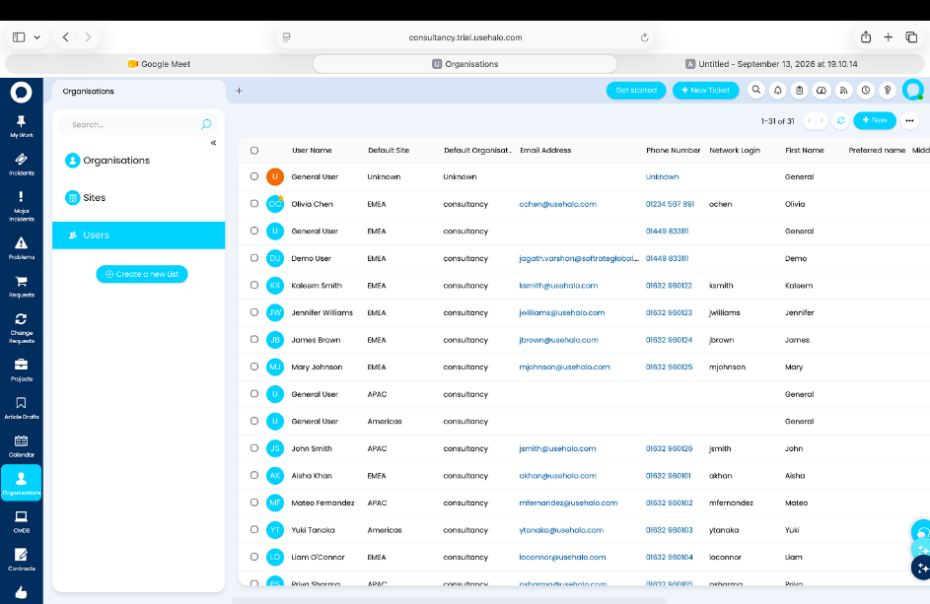
UI Components:
- User table/list
- Search/filter controls
- Navigation controls
Displayed Information:
- Username
- Default Site
- Default Organisation
- Phone Number
Navigation:
Users can select a user record for further information, where applicable.

CMDB – Service CIs (Live)
Purpose:
Provides the live list of service configuration items within the CMDB.
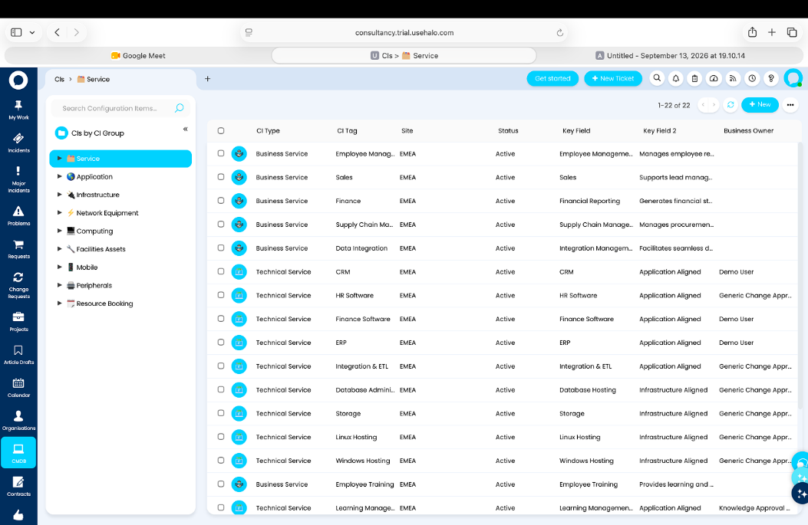
UI Components:
- Service CI table
- Search/filter controls
- Status indicators
- Navigation controls
Displayed Information:
- CI Type
- CI Tag
- Site
- Status
- Key Field
Navigation:
Users can select a service CI to access its relevant information.

My Approvals (Live)
Purpose:
Allows users to review and manage approval requests in the live application.
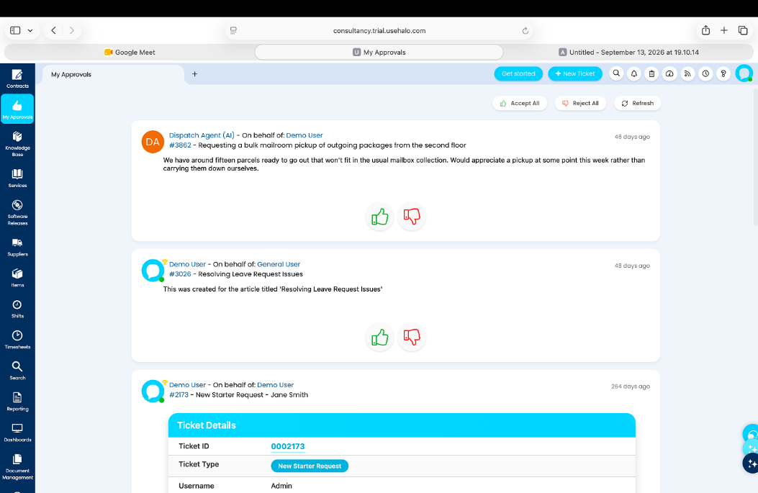
UI Components:
- Approval list
- Request information
- Status indicators
- Approval/action controls
Displayed Information:
- Requests awaiting approval
- Request status
- Approval-related information
Navigation:
Users can select an approval item to review its details.

Services Catalogue (Live)
Purpose:
Provides access to the available services in the live application.
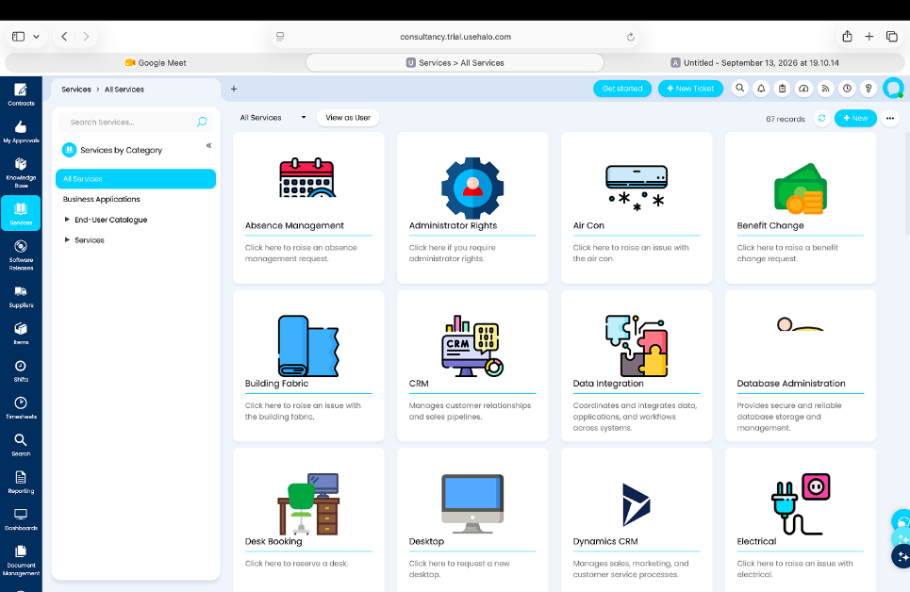
UI Components:
- Service list/cards
- Service categories
- Search/filter controls, where available
Displayed Information:
- Available services
- Service categories
- Service-related information
Navigation:
Users can select a service to access its details or related service options.

Article Drafts (Design)
Purpose:
Provides the designed interface for viewing article drafts.
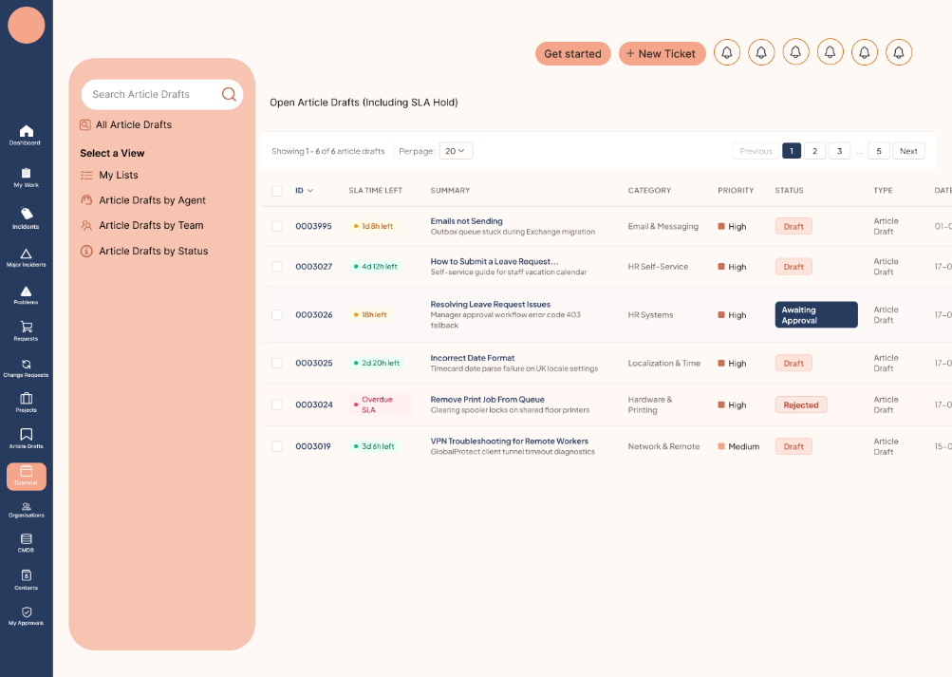
UI Components:
- Article list
- Article information
- Status indicators
- Search/filter controls
Displayed Information:
- Article drafts
- Article status
- Related article information
Navigation:
Users can select an article draft to access its details.

Calendar (Design)
Purpose:
Provides the designed calendar interface for viewing scheduled activities and events.
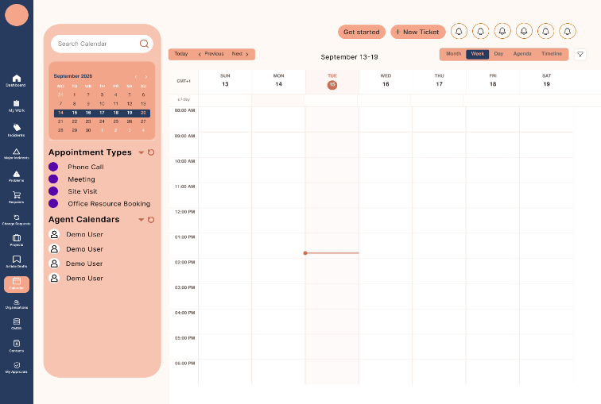
UI Components:
- Calendar grid
- Date navigation
- Event entries
- Calendar controls
Displayed Information:
- Dates
- Scheduled activities/events
- Calendar information
Navigation:
Users can navigate between dates and available calendar views.

SCR-001 – Login
Purpose
Allows users to securely access Halo AI using their username and password.
Users
- Service User
- Service Agent
- Approver
- Support Team User
Components
- Username field
- Password field
- Login button
Feature Requirements
- Enter Username
  - User can enter their username.
- Enter Password
  - User can enter their password.
- Login
  - User can select the Login button to access Halo AI.
- User Authentication
  - The system checks the entered username and password before allowing access.
- Access Halo AI
  - After successful login, the user can access the Halo AI system.

Validation
- Username is required.
- Password is required.
- Login should be allowed only when valid login details are provided.
Navigation
- Login → Halo AI Dashboard / Home

SCR-002– Dashboard
Purpose
Provides a personalized overview of the logged-in user's tickets, approvals, assignments, and tasks.
Users
- Service User
- Service Agent
- Approver
- Support Team User
Components
- Tickets overview
- Approvals overview
- Assignments overview
- Tasks overview
- Dashboard navigation
Feature Requirements
- View Tickets
- User can view their ticket information from the dashboard.
- View Approvals
- User can view their pending approval information.
- View Assignments
- User can view the work or tickets assigned to them.
- View Tasks
- User can view their assigned tasks.
- Personalized Dashboard
- The dashboard displays information related to the logged-in user.
- Dashboard Overview
- User can see important service-related information in one place.
- Navigate to Other Screens
- User can use the dashboard navigation to access other Halo AI sections.

Validation
- The dashboard shall present information relevant to the currently logged-in user.
- The ticket, approval, assignment, and task information areas shall show the corresponding information if any.
- If none of the aforementioned information is present, the source shall not specify the empty-state message.

SCR-003 – Incidents
Purpose
Displays incident analytics with priority and category charts, recent incidents, and new tickets.
Users
- Service User
- Service Agent
- Support Team User
Components
- Incident priority chart
- Incident category chart
- Recent incidents section
- New tickets section
- Incident information
Feature Requirements
- View Incident Analytics
  - User can view an overview of incident information.
- View Priority Chart
  - User can view incidents grouped by priority.
- View Category Chart
  - User can view incidents grouped by category.
- View Recent Incidents
  - User can view recently created or updated incidents.
- View New Tickets
  - User can view new tickets related to incidents.

- View Incident Details
  - User can view the available information related to incidents from the page.
- Incident Overview
  - The page provides a single view of important incident information.
Validation
    - Incident information should be displayed when available.
    - Priority information should be shown in the priority chart.
    - Category information should be shown in the category chart.
    - Recent incidents should be displayed when available.
    - New tickets should be displayed when available.

Navigation
Login → Dashboard → Incidents
SCR-004 – My Work - Ticket List (Collapsed Nav)
Purpose
Shows the agent’s personal ticket queue organized by Active, Pending, and Actioned status.
Users
- Service Agent
- Support Team User
Components
- Collapsed Navigation
- My Work section
- Active tickets
- Pending tickets
- Actioned tickets
- Ticket list
Feature Requirements
- View My Work
- The agent can open the My Work section.
  - The system displays the agent’s personal ticket queue.
- View Active Tickets
  - The agent can view tickets under Active.
  - Active tickets are shown in the ticket list.
- View Pending Tickets
  - The agent can view tickets under Pending.
  - Pending tickets are shown in the ticket list.
- View Actioned Tickets
  - The agent can view tickets under Actioned.
  - Actioned tickets are shown in the ticket list.
- View Ticket Information
  - The ticket list displays the available information for each ticket.
- Collapsed Navigation
  - The screen uses the collapsed navigation layout shown in the UI design.
Validation
- The ticket list should show the agent's available tickets.
- Active, Pending, and Actioned tickets should appear under their respective sections.
- If no tickets are available, the source does not specify what empty-state message should be shown.

SCR-005 – Projects
Purpose
Shows the active projects and their progress.
Users
- Service Agent
- Support Team User
Components
- Active Projects
- Completion Status
- Project Timeline
- Time Spent
- Sub-tasks

Feature Requirements
- View Active Projects
  - Users can see the projects that are currently active.
- View Completion Status
  - Users can see how much of each project is completed.
- View Project Timeline
  - Users can see the timeline of the project.
- View Time Spent
  - Users can see the time spent on the project.
- View Sub-tasks
  - Users can see the sub-tasks related to each project.
Validation
- Active project information should be displayed correctly.
- Completion status, timeline, time spent, and sub-task information should be shown when available.
Navigation
Login → Dashboard → Projects
SCR-006 – Services Catalogue
Purpose
Allows users to view available services by category and submit service requests.
Users
- Service User
- Service Agent
Components
- Services Catalogue
- Service Categories
- Service List
- Service Details
- Request Service option

Feature Requirements
- View Services
  - Users can view the available services in the catalogue.
- View Services by Category
  - Services are grouped into different categories.
  - Users can select a category to view its services.
- View Service Details
  - Users can select a service and view its available information.
- Submit Service Request
  - Users can select a service and submit a request.
- Service Catalogue Navigation
  - Users can move between service categories and available services.
Validation
- Services should be displayed under the correct category.
- Service information should be shown when available.
- A service request can be submitted for an available service.
Navigation
Login → Dashboard → Services Catalogue → Select Category → Select Service → Submit Request
SCR-007 – My Approvals
Purpose
Shows pending approval requests and allows the user to approve or reject them.
Users
- Approver
Components
- Pending Approval Requests
- Approval Request List
- Approve button
- Reject button
- Request Details

Feature Requirements
- View Pending Requests
  - User can see all pending approval requests.

- View Request Details
  - User can view the details of an approval request.
- Approve Request
  - User can click Approve to approve a request.
- Reject Request
  - User can click Reject to reject a request.
- View Approval Status
  - User can see the status of the approval request.
Validation
- Only pending approval requests should be shown.
- Approve and Reject options should be available for pending requests.
- The approval status should update after the user takes an action.
Navigation
Login → Dashboard → My Approvals
SCR-008 – My Work - On Hold Tickets
Purpose
Allows agents to view and manage on-hold tickets with SLA and priority details.
Users
- Service Agent
- Support Team User
Components
- Ticket View Options
- On-Hold Tickets List
- SLA Details
- Priority Details
- Ticket Details

Feature Requirements
- View On-Hold Tickets
  - Agent can see tickets that are currently on hold.
- Switch Ticket Views
  - Agent can switch between the available ticket views.
- View SLA Details
  - Agent can see the SLA information for each on-hold ticket.
- View Priority
  - Agent can see the priority of each ticket.
- View Ticket Details
  - Agent can select a ticket and view its details.
Validation
- Only on-hold tickets should be shown in this view.
- SLA and priority information should be displayed when available.
- The selected ticket view should show the correct tickets.
Navigation
Login → Dashboard → My Work → On Hold Tickets
SCR-009 – Change Requests
Purpose
Shows all change requests with their status, type, CI tag, and scheduled dates.
Users
- Service Agent
- Support Team User
Components
- Change Request List: Shows all available change requests in a clear list or table format.
- Status: Shows the status of each request, such as Active, Pending, or Completed.
- Change Type: Shows the type of change request.
- CI Tag: Shows the Configuration Item (CI) linked to the change request.
- Scheduled Dates: Shows the planned start and end dates for the change.
- Request Details: Allows the user to select a request and view its details.

Feature Requirements
- View Change Requests
  - Users can see all change requests.
- View Status
  - Users can see the status of each request.
- View Change Type
  - Users can see the type of each request.
- View CI Tag
  - Users can see the CI tag linked to the request.
- View Scheduled Dates
  - Users can see the planned start and end dates.
- View Request Details
  - Users can select a request to see more details.
Validation
- Change request information should be displayed correctly.
- Status, type, CI tag, and dates should be shown when available.
Navigation
Login → Dashboard → Change Requests

SCR-010 – New List - Create List Form
Purpose
Allows users to create a custom ticket list by entering a list name, selecting a group, choosing a column profile, and setting how the list is displayed.
Users
- Service Agent
- Support Team User
Components
- List Name: Text field where the user enters the name of the new ticket list.
- Group: Selection field where the user chooses the group for the ticket list.
- Column Profile: Selection field where the user chooses which ticket information should be shown as columns.
- Display Settings: Settings that control how the ticket list is displayed.

- Create / Save Button: Button used to create and save the custom ticket list.
Feature Requirements
- Enter List Name
- User can enter a name for the ticket list.
- Select Group
  - User can select a group for the list.
- Select Column Profile
  - User can choose the column profile for the list.
- Set Display Settings
  - User can set the available display options.
- Create Custom List
  - User can create the ticket list using the selected settings.
Validation
- List name should be entered before creating the list.
- Required selections should be completed.
- The system should create the list using the selected settings.
Navigation
Login → Dashboard → My Work → New List → Create List
SCR-011 – Incidents by Team - 1st Line Support (Design)
Purpose
Shows open incidents assigned to 1st Line Support agents, along with their SLA timers and priority.
Users
- Service Agent
- Support Team User
Components
- Incident List: Shows the open incidents assigned to the 1st Line Support team.
- Incident Information: Shows the basic information of each incident.
- SLA Timer: Shows the remaining SLA time for each incident.
- Priority: Shows the priority level of each incident.
- 1st Line Support Team: Identifies that the displayed incidents belong to the 1st Line Support team.
Feature Requirements
- View Open Incidents
  - Users can see open incidents assigned to 1st Line Support.
- View Incident Information
  - Users can see the available details of each incident.
- View SLA Timer
  - Users can see the SLA timer for each incident.
- View Priority
  - Users can see the priority of each incident.
- View Team
  - The page shows incidents handled by the 1st Line Support team.
Validation
- Only open incidents assigned to 1st Line Support should be shown.
- SLA timer and priority should be displayed for each incident when available.
Navigation
Login → Dashboard → Incidents by Team → 1st Line Support

SCR-012 – Incidents by Team - 2nd Line Support (Design)
Purpose
Shows open incidents under 2nd Line Support with SLA countdown and priority.
Users
- Service Agent
- Support Team User
Components
- Incident List: Shows the open incidents handled by the 2nd Line Support team.
- Incident Information: Shows the available information for each incident.
- SLA Countdown: Shows the remaining time for the SLA of each incident.
- Priority: Shows the priority level of each incident.
- 2nd Line Support Team: Shows that the incidents belong to the 2nd Line Support team.
Feature Requirements
- View Open Incidents
  - Users can see open incidents under 2nd Line Support.
- View Incident Information
  - Users can see the available details of each incident.
- View SLA Countdown
  - Users can see the remaining SLA time for each incident.
- View Priority
  - Users can see the priority of each incident.
- View Support Team
  - The page shows incidents handled by the 2nd Line Support team.
Validation
- Only open incidents under 2nd Line Support should be shown.
- SLA countdown and priority should be displayed when available.
Navigation
Login → Dashboard → Incidents by Team → 2nd Line Support
SCR-013 – Splash / Sign-In Loading Screen
Purpose
Shows a loading screen after login while the system loads the user's session.
Users
- Service User
- Service Agent
- Approver
- Support Team User
Components
- Loading Screen: Displays while the system is loading.
- Loading Indicator: Shows that the system is processing the login and loading the session.
- Halo AI Branding: Displays the system branding shown in the UI design.

Feature Requirements
- Show Loading Screen
  - The loading screen appears after successful authentication.
- Load User Session
  - The system loads the user's session in the background.
- Move to Dashboard
  - After the session is loaded, the user is taken to the main system screen.
Validation
- The loading screen should appear after successful authentication.
- The loading screen should remain visible while the session is loading.
Navigation
Login → Splash / Sign-In Loading → Dashboard
SCR-014 – Home Dashboard (Live)
Purpose
Shows a live overview of important service information, including open incidents, SLA breaches, resolution times, and mood check-in.
Users
- Service User
- Service Agent
- Support Team User
Components
- Open Incidents: Shows the number of incidents that are currently open.
- SLA Breaches: Shows incidents where the SLA has been breached.
- Resolution Time: Shows information about the time taken to resolve incidents.
- Mood Check-in: Allows the user to provide a mood check-in.
- Live Dashboard: Displays the latest available service information on the dashboard.
Feature Requirements
- View Open Incidents
  - Users can see the current number of open incidents.
- View SLA Breaches
  - Users can see the number of SLA breaches.
- View Resolution Times
  - Users can view incident resolution time information.
- Mood Check-in
  - Users can provide their mood check-in.
- View Live Information
  - The dashboard displays the latest available information.
Validation
- KPI information should be displayed correctly when data is available.
- Mood check-in should be available to the user.
- Dashboard information should reflect the latest available data.
Navigation
Login → Dashboard → Home Dashboard

SCR-015 – Home Dashboard - Scrolled View (Live)
Purpose
Shows more information on the live dashboard, including incidents by team, incident categories, and new tickets.
Users
- Service User
- Service Agent
- Support Team User
Components
- Incidents by Team: Shows the number or details of incidents for each support team.
- Category Breakdown: Shows incidents grouped by their category.
- New Tickets Panel: Shows the latest new tickets available in the system.
- Dashboard Content: Displays the additional information when the user scrolls down the dashboard.

Feature Requirements
- View Incidents by Team
  - Users can see incidents grouped by support team.
- View Category Breakdown
  - Users can see incidents grouped by category.
- View New Tickets
  - Users can see the latest new tickets.
- Scroll Dashboard
  - Users can scroll down to view the additional dashboard information.
Validation
- Team, category, and new ticket information should be displayed when data is available.
- The information should match the latest available dashboard data.
Navigation
Login → Home Dashboard → Scroll Down
SCR-016 – My On Hold Tickets (Live)
Purpose
Shows all on-hold tickets with their type, SLA time, priority, organisation, and status.
Users
- Service Agent
- Support Team User
Components
- On-Hold Ticket List: Shows all tickets that are currently on hold.
- Ticket Type Filter: Allows the user to filter tickets by type.
- SLA Time: Shows the SLA time for each ticket.
- Priority: Shows the priority of each ticket.
- Organisation: Shows the organisation related to the ticket.
- Status: Shows the status of the ticket.
- Ticket Details: Shows the available information about the selected ticket.
Feature Requirements
- View On-Hold Tickets
  - Users can see all on-hold tickets.
- Filter by Type
  - Users can filter tickets based on their type.
- View SLA Time
  - Users can see the SLA time for each ticket.
- View Priority
  - Users can see the priority of each ticket.
- View Organisation
  - Users can see the organisation linked to the ticket.
- View Status
  - Users can see the status of each ticket.
Validation
- Only on-hold tickets should be displayed.
- The ticket type filter should show the correct tickets.
- SLA time, priority, organisation, and status should be shown when available.
Navigation
Login → Dashboard → My Work → My on Hold Tickets

SCR-017 – New List - Create List Form (Live)
Purpose
Allows users to create a custom ticket list by setting the list name, scope, group, and column profile.
Users
- Service Agent
- Support Team User
Components
- List Name: Text field where the user enters the name of the new list.
- Scope: Selection field used to choose the scope of the ticket list.
- Group: Selection field used to choose the group for the list.
- Column Profile: Selection field used to choose which ticket information is shown in the list.
- Create / Save Button: Button used to create and save the custom ticket list.
Feature Requirements
- Enter List Name
  - User can enter a name for the list.
- Select Scope
  - User can select the scope for the list.
- Select Group
  - User can select a group for the list.
- Select Column Profile
  - User can select the column profile.
- Create Custom List
  - User can create the ticket list using the selected settings.
Validation
- List name should be entered.
- Scope, group, and column profile should be selected as required.
- The list should be created using the selected settings.
Navigation
Login → Dashboard → My Work → New List → Create List

SCR-018 – Incidents by Team - 1st Line Support (Live)
Purpose
Shows live open incidents for 1st Line Support, along with agent availability and SLA countdown.
Users
- Service Agent
- Support Team User
Components
- Open Incident List: Shows the incidents that are currently open under 1st Line Support.
- Agent Availability: Shows the availability of 1st Line Support agents.
- SLA Countdown: Shows the remaining SLA time for each incident.
- Incident Details: Shows the available information about each incident.
- 1st Line Support: Shows that the incidents belong to the 1st Line Support team.
Feature Requirements
- View Open Incidents: Users can see the live open incidents.
- View Agent Availability: Users can see the availability of 1st Line Support agents.
- View SLA Countdown: Users can see the remaining SLA time for each incident.
- View Incident Details: Users can see the available details of each incident.
- View Live Information: The page shows the latest available incident information.
Validation
- Only open incidents under 1st Line Support should be displayed.
- Agent availability should be shown when available.
- SLA countdown should be shown for the incidents.
Navigation
Login → Dashboard → Incidents by Team → 1st Line Support

SCR-019 – Incidents by Team - 2nd Line Support (Live)
Purpose
Shows live open incidents for 2nd Line Support, along with the agent list and ticket details.
Users
- Service Agent
- Support Team User
Components
- Open Incident List: Shows the incidents that are currently open under 2nd Line Support.
- Agent List: Shows the agents available under the 2nd Line Support team.
- Ticket Details: Shows the available information about each incident or ticket.
- 2nd Line Support: Shows that the incidents belong to the 2nd Line Support team.
- Live Information: Shows the latest available incident and ticket information.
Feature Requirements
- View Open Incidents
  - Users can see live open incidents.
- View Agent List
  - Users can see the 2nd Line Support agent list.
- View Ticket Details
  - Users can view the details of a selected ticket.
- View Live Information
  - Users can see the latest available information.

Validation
- Only open incidents under 2nd Line Support should be displayed.
- The agent list should show the available team information.
- Ticket details should be displayed when available.
Navigation
Login → Dashboard → Incidents by Team → 2nd Line Support
SCR-020 – Organisations - Users List (Design)
Purpose
Shows organisation users with their site, email, phone number, and network login details.
Users
- Service Agent
- Support Team User
Components
- Users List: Shows the users belonging to the organisation.
- Username: Shows the name of each organisation user.
- Site: Shows the site or location linked to the user.
- Email: Shows the user's email address.
- Phone Number: Shows the user's phone number.
- Network Login: Shows the user's network login details.
Feature Requirements
- View Organisation Users
  - Users can see the list of organisation users.
- View Site
  - Users can see the site linked to each user.
- View Email
  - Users can see the user's email address.
- View Phone Number
  - Users can see the user's phone number.
- View Network Login
  - Users can see the network login details.

Validation
- User information should be displayed correctly when available.
- Site, email, phone number, and network login details should be shown for the listed users.
Navigation
Login → Dashboard → Organisations → Users List

SCR-021 – Major Incidents with Activity Feed (Design)
Purpose
Shows active major incidents with their lifecycle stages and a live activity feed.
Users
- Service Agent
- Support Team User
Components
- Major Incident List: Shows the active major incidents.
- Incident Details: Shows the available information about each major incident.
- Lifecycle Stages: Shows the current stage of each major incident in its lifecycle.
- Activity Feed: Shows the latest activities and updates related to the major incidents.
- Live Updates: Displays new incident activities as they become available.
Feature Requirements
- View Major Incidents
  - Users can see active major incidents.
- View Incident Details
  - Users can view the available details of a major incident.
- View Lifecycle Stages
  - Users can see the different stages of the incident lifecycle.
- View Activity Feed
  - Users can see activities and updates related to major incidents.
- View Live Updates
  - Users can see the latest updates in the activity feed.

Validation
- Only active major incidents should be displayed.
- Lifecycle stages should be shown for the incidents.
- The activity feed should display available incident updates.
Navigation
Login → Dashboard → Major Incidents → Activity Feed

SCR-022 – Major Incidents - Update Required (Live)
Purpose
Shows major incidents that need an update, with the full resolution process visible.
Users
- Service Agent
- Support Team User
Components
- Major Incident List: Shows major incidents that are marked as Update Required.
- Update Required Filter: Shows only the major incidents that need an update.
- Incident Details: Shows the available information about each major incident.
- Resolution Pipeline: Shows the different steps in the incident resolution process.
- Current Stage: Shows the current stage of each major incident in the resolution process.
Feature Requirements
- View Update Required Incidents
  - Users can see major incidents that require an update.
- View Incident Details
  - Users can view the details of a selected major incident.
- View Resolution Pipeline
  - Users can see the full resolution process.
- View Current Stage
  - Users can see the current stage of the incident.
- View Live Information
  - Users can see the latest available incident information.

Validation
- Only major incidents marked Update Required should be displayed.
- The resolution pipeline should be visible for the listed incidents.
- Incident information should be displayed when available.
Navigation
Login → Dashboard → Major Incidents → Update Required

SCR-023 – Major Incidents - Update Required with Feed (Live)
Purpose
Shows major incidents that need an update, with the Activity Feed open to show real-time ticket updates.
Users
- Service Agent
- Support Team User
Components
- Major Incident List: Shows major incidents marked as Update Required.
- Update Required Filter: Shows only the major incidents that need an update.
- Incident Details: Shows the available information about each major incident.
- Resolution Pipeline: Shows the different steps in the incident resolution process.
- Activity Feed: Shows the latest activities and updates related to the selected incident.
- Real-Time Ticket Updates: Shows new ticket updates as they are added.
Feature Requirements
- View Update Required Incidents
  - Users can see major incidents that need an update.
- View Incident Details
  - Users can view the details of a major incident.
- View Resolution Pipeline
  - Users can see the incident resolution steps.
- View Activity Feed
  - Users can view the activity feed for the incident.
- View Real-Time Updates
  - Users can see new ticket updates in the activity feed.
Validation
- Only major incidents marked Update Required should be displayed.
- The Activity Feed should be visible on the screen.
- New ticket updates should appear in the Activity Feed when available.
Navigation
Login → Dashboard → Major Incidents → Update Required → Activity Feed

SCR-024 – CMDB Configuration Items (Design)
Purpose
Shows all configuration items (CIs) grouped by type, with their CI tag, site, status, and business owner.
Users
- Service Agent
- Support Team User
Components
- Configuration Item List: Shows all available configuration items.
- CI Type: Groups the configuration items based on their type.
- CI Tag: Shows the tag or ID of each configuration item.
- Site: Shows the site linked to the configuration item.
- Status: Shows the status of the configuration item.
- Business Owner: Shows the business owner linked to the configuration item.
Feature Requirements
- View Configuration Items
  - Users can see the available configuration items.
- View by Type
  - Configuration items are grouped by type.
- View CI Tag
  - Users can see the CI tag for each item.
- View Site
  - Users can see the site linked to each item.
- View Status
  - Users can see the status of each item.
- View Business Owner
  - Users can see the business owner of each item.
Validation
- Configuration items should be grouped by type.
- CI tag, site, status, and business owner should be shown when available.
Navigation
Login → Dashboard → CMDB → Configuration Items

SCR-025 – Major Incidents List View (Mockup)
Purpose
Shows major incidents as incident cards with lifecycle stages, priority, and product tags.
Users
- Service Agent
- Support Team User
Components
- Incident Cards: Each major incident is shown as a separate card with its main information.
- Lifecycle Pipeline: Shows the current stage and progress of the incident.
- Priority Badge: Shows the priority of the major incident.
- Product Tags: Shows the products related to the major incident.
Feature Requirements
- View Major Incidents
  - Users can see major incidents as cards.
- View Lifecycle Pipeline
  - Users can see the incident lifecycle stages.
- View Priority
  - Users can see the priority of each incident.
- View Product Tags
  - Users can see the products linked to each incident.

Validation
- Each major incident should be displayed as a separate card.
- Lifecycle, priority, and product information should be shown when available.
Navigation
Login → Dashboard → Major Incidents → List View

SCR-026 – Change Requests - All Active Changes (Live)
Purpose
Shows a live list of active change requests with agent, change type, status, CI tags, and start and end dates.
Users
- Service Agent
- Support Team User
Components
- Active Change List: Shows all currently active change requests.
- Agent: Shows the agent linked to each change request.
- Change Type: Shows the type of change request.
- Status: Shows the status of the change.
- CI Tags: Shows the configuration items linked to the change.
- Start Date: Shows when the change is planned to start.
- End Date: Shows when the change is planned to end.
Feature Requirements
- View Active Changes
  - Users can see all active change requests.
- View Agent
  - Users can see the agent assigned to each change.
- View Change Type
  - Users can see the type of each change.
- View Status
  - Users can see the status of each change.
- View CI Tags
  - Users can see the CI tags linked to each change.
- View Start and End Dates
  - Users can see the planned start and end dates.
Validation
- Only active change requests should be displayed.
- Agent, change type, status, CI tags, and dates should be shown when available.
Navigation
Login → Dashboard → Change Requests → All Active Changes

SCR-027 – Projects Active - Projects (Live)
Purpose
Shows live project information, including completion percentage, timeline, time spent, and linked sub-tasks.
Users
- Service Agent
- Support Team User
Components
- Active Projects List: Shows the projects that are currently active.
- Completion Percentage: Shows how much of each project has been completed.
- Project Timeline: Shows the timeline or planned dates for the project.
- Time Spent: Shows the time spent on each project.
- Linked Sub-Tasks: Shows the sub-tasks connected to each project.
Feature Requirements
- View Active Projects
  - Users can see the active projects.
- View Completion Percentage
  - Users can see the completion percentage of each project.
- View Timeline
  - Users can see the project timeline.
- View Time Spent
  - Users can see the time spent on the project.
- View Linked Sub-Tasks
  - Users can see the sub-tasks linked to the project.
Validation
- Only active projects should be displayed.
- Completion percentage, timeline, time spent, and sub-task details should be shown when available.
Navigation
Login → Dashboard → Projects → Active Projects

